Ann Proctor

**BUI Xuan Phai** (**Bùi Xuân Phái,**1920-1988)

Bùi Xuân Phái is famous for his paintings of the streets of his birthplace, Hanoi. Graduating from the École des Beaux-Arts d’Indochine, Hanoi, in 1946, Phái painted with the resistance group of artists but returned to Hanoi in 1952 for the birth of his first child. Due to his participation in the *Nhan Van, Giai Phan* affair, which sought to separate art and politics, he lost his teaching post at the Hanoi College of Fine Arts where he had been a lecturer (1955-57). Phái contributed illustrations and cartoons to many publications throughout his lifetime, including the two publications after which the aforementioned affair was named. During the Second Indochina war he was part of a group of artists who travelled to various places in the countryside recording events. Quintessential Bùi Xuân Phái works are intimate oil and gouache cityscapes capturing the essence of Hanoi’s ancient quarter prior to economic renovation beginning in 1986. The simplified shapes are boldly outlined in black, while the greys and dull browns of the buildings are echoed in leaden skies. Reflecting a time of war and its aftermath, the streets are sparsely inhabited by occasional pedestrians or bicycle riders.

Phái’s subject matter also included a large number of portraits, nude studies, landscapes, still-lives and abstract works. Another distinctive group of his paintings is the colourful depictions of actors and actresses from the Chèo opera. From 1958-1970 he worked with the Hanoi Opera troupe as a stage designer, though his paintings focused on the performers capturing the essence of their roles with an economy of means. In 1986 Phái was asked to complete illustrations for 18th century poet, Hồ Xuân Hương, including paintings of the poet herself as well as illustrations for her poems.

Phái was particularly fond of Matisse and Picasso, referring to them often in his copious diary notes. These notes also indicate the importance for him of artlessness and the necessity of constant work: he painted and drew anything that was available. As the country recovered from war, Phái’s works increased in size and in intensity of palette, due in some part to the increased availability of painting materials. During the 1980s he sold many works to foreigners. Although he received numerous prizes at the national level, he had only one solo exhibition during his lifetime in 1984. However, three posthumous shows were held in 1989, 1990 and 1992. Phái’s official reputation was cemented by the 1996 award of the Ho Chi Minh prize for his contribution to Vietnamese culture.

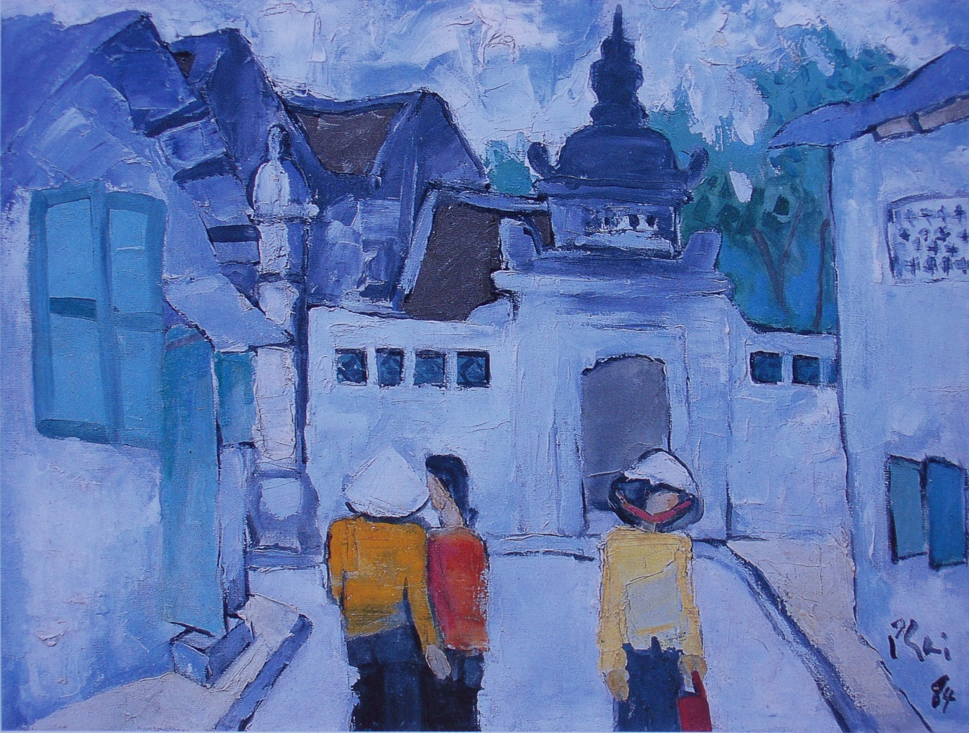

**Bùi Xuân Phái** (1920-1988) Phất Lộc Alley, 1984, oil on canvas, 60 x 80 cm, Vietnam Fine Arts Museum, Hanoi

**References and further reading**

Bùi Xuân Phái (2008) *Under the light of an Oil Lamp*, Hanoi: Nhà Xuất Bản Mỹ Thuật. (The note books of the artist with a foreword by the collector Trần Hậu Tuấn).

Noppe Catherine et Jean François Hubert, (2003) *Art of Vietnam*, New York: Parkstone Press

(A discussion of the French influence on Vietnamese painting and a translation of Tô Ngọc Vân’s asessment of Bùi Xuân Phái).

Taylor, Nora, Annesley. (2004) *Painters in Hanoi: An Ethnography of Vietnamese Art*, Honolulu: University of Hawai’i Press. (Taylor analyses the trajectory of Bùi Xuân Phái’s career, discussing his problematic rise to stardom as well as the issue of forgeries of his work since his death.)